Database schema design

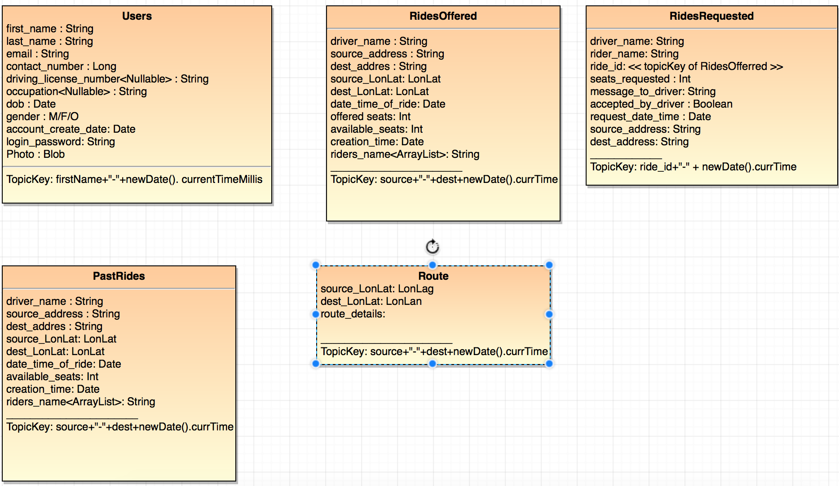

Salient points:

* we are not saving data in a RDBMS structure and so there will be data duplication for easy access. we have to think from a NoSql db approach.
* we are not going to have the functionality of database joins. So I have eliminated the UserId column as this seems to be redundant unless we are able to join.
* Photo: Saving photo in Blob cannot/shouldn’t be done if we are just using persistence store as this will surely take up space of the map. So, we should store somewhere in the db and save the id in the User’s table. Some, max size should be specified.
* The RidesOffered table will have a arraylist of user’s accepting the rides. There is also a column saying available seats that is to be decreased each time a person joins a ride.
* There is no such primary key. I have included TopicKey in the tables going by the way of example in the Gateway code. However, it usually has a timestamp part to make it unique. Going by this way, even though we are not using RDMBS, we are partly taking this approach.
* I have used LonLat in some places. This is supposed to be the Longitude and Latitude as per Google maps. Though I do not have much idea, this is the purpose of these fields. Can be kept Null/empty if required.
* PastRides: Rides that expired (after the time is over). We should have some mechanism to copy data from offeredRides table to PastRides table after the time is over
* Route is an extra table which is for future use. In case we start using Google maps, we may need to store the route and details about that and use it.